Joshua, Nathan, Hasan
Youtube Video Link:
https://youtube.com/shorts/FE4bWQORaz8

Photo:
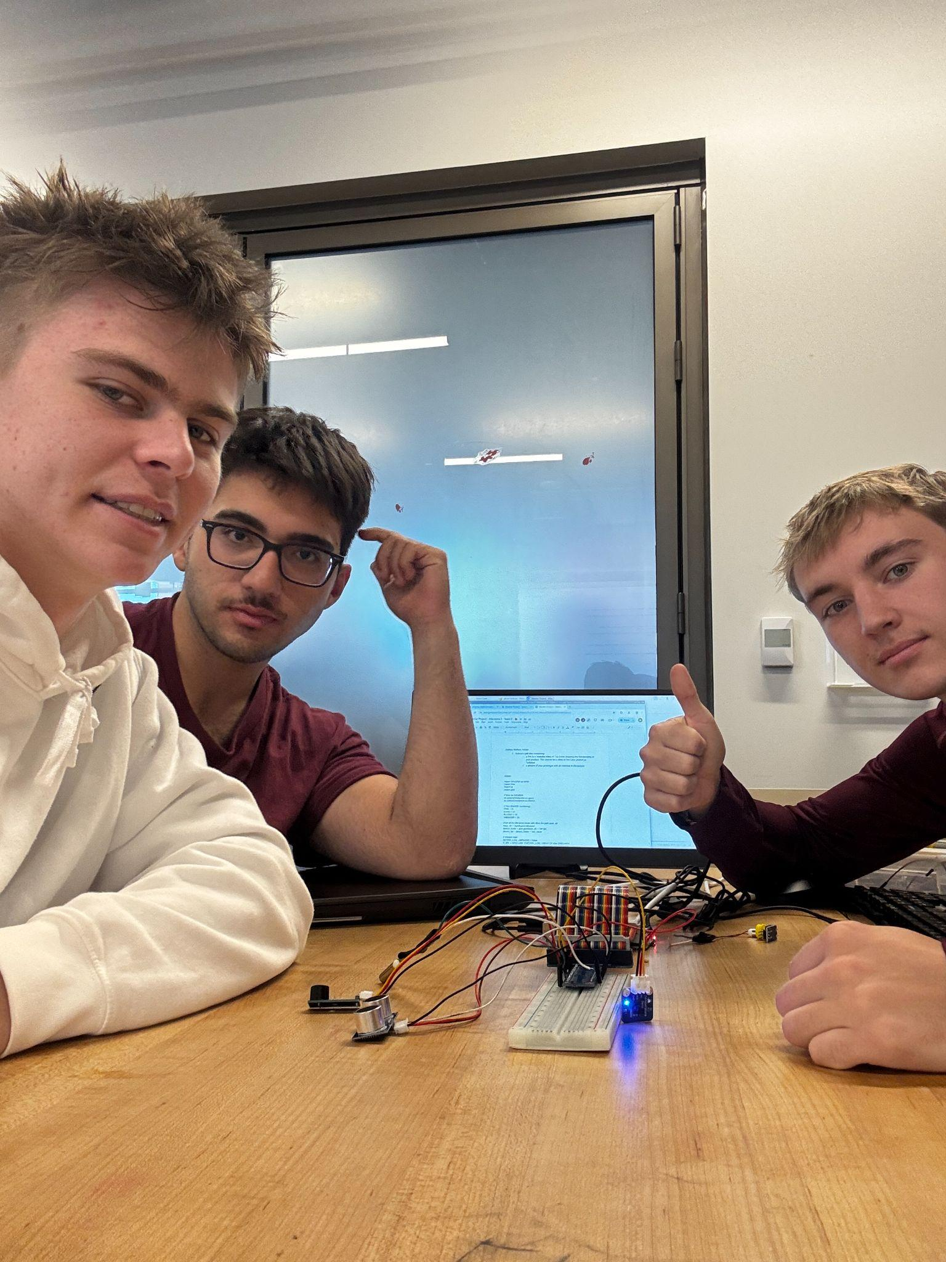

CODE:

import RPi.GPIO as GPIO
import time
import os
import glob

# Wire for DS18B20
os.system('modprobe w1-gpio')
os.system('modprobe w1-therm')

# Pins (BOARD numbering)
TRIG = 11
ECHO = 12
BUZZER = 13
VIBRATOR = 15

#Get all the filenames begin with 28 in the path base_dir
base_dir = '/sys/bus/w1/devices/'
device_folder = glob.glob(base_dir + '28*')[0]
device_file = device_folder + '/w1_slave'

# Vibrator logic
ACTIVE_LOW_VIBRATOR = False
V_ON = GPIO.LOW if ACTIVE_LOW_VIBRATOR else GPIO.HIGH
V_OFF = GPIO.HIGH if ACTIVE_LOW_VIBRATOR else GPIO.LOW

def setup():
#Setup the GPIO pins for Buzzer,Vibrator, and Ultrasonic Sensor
GPIO.setmode(GPIO.BOARD)

# Ultrasonic
GPIO.setup(TRIG, GPIO.OUT)
GPIO.setup(ECHO, GPIO.IN)

# Outputs
GPIO.setup(BUZZER, GPIO.OUT, initial=GPIO.LOW)
GPIO.setup(VIBRATOR, GPIO.OUT, initial=V_OFF)

def distance():
# Measure the distance with ultrasonic sensor

GPIO.output(TRIG, 0)
time.sleep(0.000002)
GPIO.output(TRIG, 1)
time.sleep(0.00001)
GPIO.output(TRIG, 0)

while GPIO.input(ECHO) == 0:
pass
time1 = time.time()

while GPIO.input(ECHO) == 1:
pass
time2 = time.time()

duration = time2 - time1
return (duration * 340 / 2) * 100 # Convert to centimeters

def buzzer_on():
# Set buzzer on
GPIO.output(BUZZER, GPIO.LOW)

def buzzer_off():
# Set buzzer of
GPIO.output(BUZZER, GPIO.HIGH)

def vibrator_on():
# Set vibrator on
GPIO.output(VIBRATOR, V_ON)

def vibrator_off():
# Set vibrator off
GPIO.output(VIBRATOR, V_OFF)

def beep(duration):
# Set the beep for a specified duration
buzzer_on()
time.sleep(duration)
buzzer_off()
time.sleep(duration)

#For temperature sensor
def read_rom():
name_file=device_folder+'/name'
f = open(name_file,'r')
return f.readline()

def read_temp_raw():
f = open(device_file, 'r')
lines = f.readlines()
f.close()
return lines

def read_temp():
lines = read_temp_raw()
#Analyze if the last 3 characters are "YES"
while lines[0].strip()[-3:] != 'YES':
time.sleep(0.2)
lines = read_temp_raw()
#Fix the index of t= in the string
equals_pos = lines[1].find('t=')
if equals_pos != -1:
temp_string = lines[1][equals_pos+2:]
temp_c = float(temp_string) / 1000.0
temp_f = temp_c * 9.0 / 5.0 + 32.0
return temp_c, temp_f

def loop():
# Main loop that checks the distance,temperature and controls the buzzer and vibrator
while True:
dis = distance()
temp_celsius , temp_fahrenheit = read_temp()
print(dis, 'cm') # Print distance measurement
print(f"temp: {temp_fahrenheit}")
if dis < 10: # If the object is within 5 cm, vibrate continuously
vibrator_on()
else:
# Turn off vibrator if object is far
vibrator_off()

if temp_fahrenheit > 120: # If the object is within 5 cm, buzz continuously
buzzer_on()
elif temp_fahrenheit < 100 and temp_fahrenheit > 80 : # If within 100 and 120 fahrenheit, beep with decreasing interval
beep_interval = (temp_fahrenheit - 60) / 50.0 # Adjust beep interval
beep(beep_interval)
else:
buzzer_off() # Turn off buzzer if object is far

time.sleep(0.3)

def destroy():
# Cleanup function to reset GPIO settings
GPIO.cleanup()

if __name__ == "__main__":
setup()
try:
loop()
except KeyboardInterrupt:
destroy()

